español video

Four Part Documentary Series Premieres on PBS Over Two Evenings October 12 and 19, 2009 (check local listings)

Latin Music USA is a film about American music. Fusions of Latin sounds with jazz, rock, country, rhythm and blues — music with deeper roots and broader reach than most people realize. It's a fresh take on our musical history, reaching across five decades and across musical genres to portray the rich mix of sounds created by Latinos and embraced by all.

The four-hour documentary series premieres on October 12th (Episodes 1&2) and October 19th (Episodes 3&4) 2009, on PBS stations nationwide and on PBS.org/latinmusicusa. Produced by a team led by WGBH, in co-production with the BBC, Latin Music USA invites the audience into the vibrant musical conversation between Latinos and non-Latinos that has helped shape the history of popular music in the United States. Fittingly, the series launches in Hispanic Heritage Month, a time to recognize the contributions of Latinos to the United States and to celebrate Latino heritage and culture.

The Latin Music USA Series

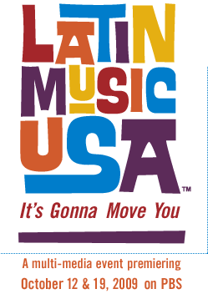

The series features the stories of an extraordinary range of artists, including salsa greats Willie Colón and Marc Anthony; the Latin-inflected sounds found in much of sixties rock and roll, from the Drifters to Motown to the Rolling Stones; jazz fused with Cuban rhythms from Mario Bauzá and Chano Pozo; the genius of Texas accordion player Flaco Jiménez; Carlos Santana; Linda Ronstadt; the legendary Chicano rock band Los Lobos; megastars Gloria and Emilio Estefan; Ricky Martin and Juanes; Miami rapper Pitbull; reggaetón performers Daddy Yankee and Tego Calderón; and Lin-Manuel Miranda from the Tony Award-winning musical In the Heights. The life experiences of these and many other unforgettable artists will reveal how Latinos have reinvented their music in the United States, while never losing sight of their own rich traditions.

Series Reaches Out to Broad Audiences

Documentary Series

The four-hour (4 X 60) documentary series features a fast-paced mix of music and interviews. It will air in English, narrated by acclaimed actor Jimmy Smits, on PBS with an available Spanish-language track. The series will also air on V-me, the fastest-growing Hispanic TV network in history, on October 13 and 20, 2009, fully translated and narrated in Spanish.

• Episode One: Traces the rise of Latin jazz and the explosion of the mambo and the cha cha chá as they sweep the US from East to West. Latin Music infiltrates R&B and rock and roll through the 1960s.

• Episode Two: Puerto Ricans and other Latinos in New York reinvent the Cuban son and the Puerto Rican plena, adding elements from soul and jazz to create salsa, which becomes a defining rhythm for Latinos the world over.

• Episode Three: Mexican-Americans in CA, TX and across the Southwest create their own distinct musical voices during the second half of the 20th century. Their music would play an important role in the struggle for Chicano civil rights and ultimately propel them from the barrio to the national stage.

• Episode Four: Focuses on the Latin pop explosion of the turn of the century and the success of artists like Ricky Martin, Gloria Estefan and Shakira in the English-language market. As studios concentrate on star-driven pop, Latino youth gravitate toward urban fusions — Spanish rap and reggaetón, as well as rock en Español.
Project Launches On-Air, Online, in Print, and in the Community
On-Air

WGBH has partnered with V-me, a Spanish language, 24-hour, digital broadcast service presented by affiliate PBS stations. V-me is also carried on basic cable in major markets and nationally via satellite. The Spanish language partnership with V-me gives Latin Music USA an extraordinary opportunity to present the series to an even wider audience.

Print and Online

People en Español, the top-selling Hispanic magazine in the United States, and its website peopleenespanol.com, will include exclusive Latin Music USA editorial features and content across both brands. The exclusive online content on the People en Español website and in the magazine will give both visitors and readers a sneak peek at interviews and concert footage from the series.
Online

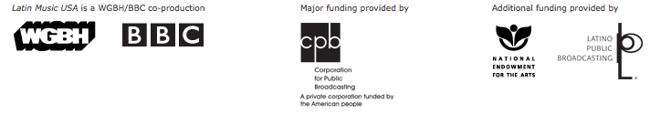
In the tradition of PBS.org — the most visited .org in the world — the Latin Music USA project is defined by its deep, bilingual website with hands-on, interactive features, dynamic clips, and a player that streams the entire series in English and Spanish.

In the Community/Cultural Relevance

What makes PBS unique as a broadcaster, and creates an additional platform, is its ability to leverage its 350 local PBS stations to develop culturally relevant programming and events at a local level. The Latin Music USA project will initiate PBS station-anchored community coalitions in five markets — Chicago, Los Angeles, Seattle, Nashville, and Baltimore — convening local partners to develop regional programming and web content, screening events, panel discussions, concerts and heritage events. The project will have a presence at a number of key music and film festivals (SXSW, NY Int. Film Fest), providing an authentic celebration of the roots and future of this uniquely American music.

National Visibility

Latin Music USA is supported by a national publicity and promotional campaign, including web and viral marketing, which will give the project lift and capitalize on its cultural currency. In addition, several other national, culturally-defining moments for the project are planned, such as a press conference at the Television Critics Association Press Tour in Los Angeles, a panel discussion/screening and reception with the Smithsonian's Latino Center in Washington, DC, and a screening and reception at the Time Warner Center in New York City.

