Lou Reed Pays Tribute To Warhol

25/06/2003 01:39 PM
Dean Goodman

As he made his own artistic statement this week by dipping his hands in wet cement on the Hollywood RockWalk, Lou Reed paid tribute to Andy Warhol, the pop artist who gave the edgy rocker his big break.

"Everything I do is from the outside and if it hadn't been for Andy, who knows whether I would have had a chance to do anything. So I owe everything to Mr. Warhol," Reed told onlookers at the event.

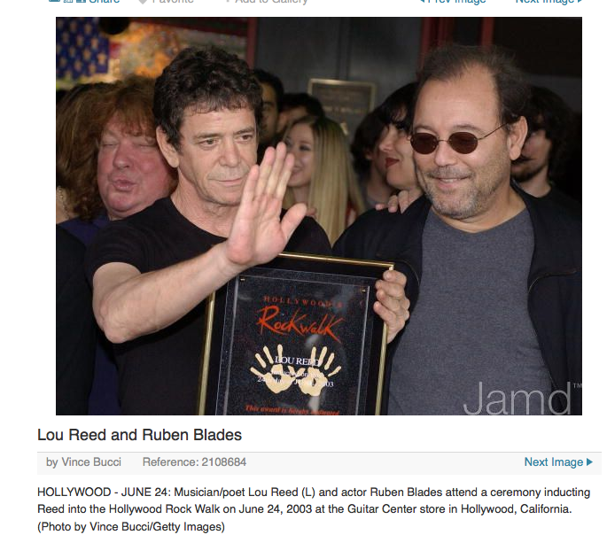
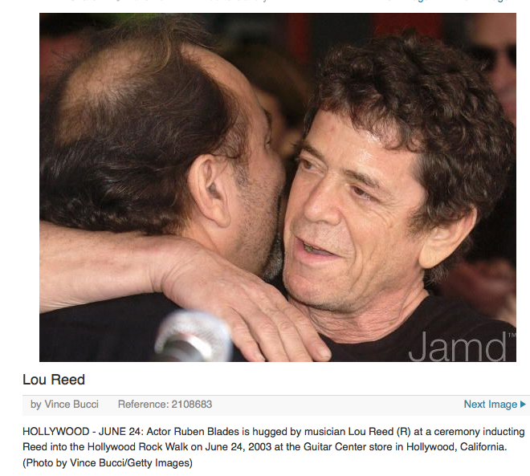
Warhol, who died in 1987, was an early champion of Reed's groundbreaking band the Velvet Underground, and is credited with producing its first record, 1967's The Velvet Underground and Nico.

A modest crowd of about 40 fans - far outnumbered by people in the VIP section - turned out for the ceremony. Reed's handprints will be displayed alongside those of such artists as AC/DC, Jimmy Page and James Brown.

He was introduced by Panamanian singer/actor/social activist Ruben Blades, who hailed Reed's "erudite yet heartfelt approach to urban realities." Comedian Richard Lewis, director Allison Anders and producer Bob Ezrin, who worked on Reed's 1973 album Berlin, also showed up.

Dressed in faded blue jeans and black t-shirt, Reed later told reporters that Warhol's favorite song was "All Tomorrow's Parties," a track from the first album.

"It's very strange. Every time I do that song, I think about him. I feel like I'm saying hello."

Reed, 61, is on tour to support two albums, the multi-artist concept project The Raven and the hits package NYC Man. He was scheduled to play the Wiltern Theatre in Los Angeles on Tuesday night.

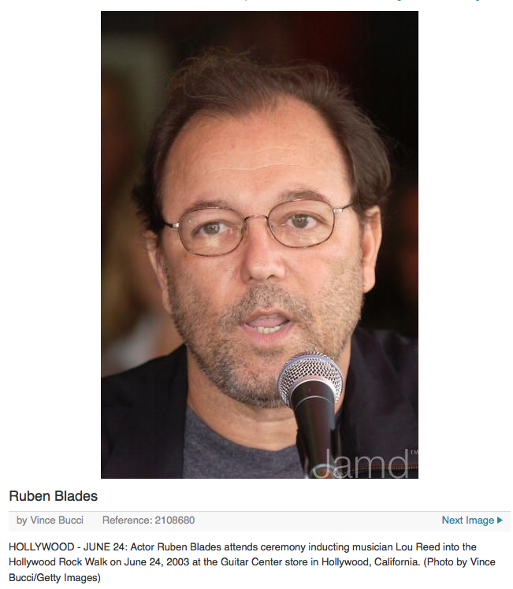
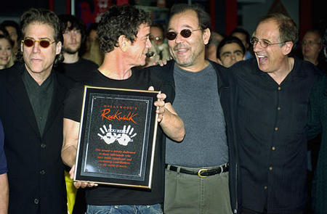
After his European tour wraps in Austria on July 28, Reed said he would publish both a book of photographs and the text of The Raven, a reworking of Edgar Allan Poe's classic poem.

"I'll never do that again," Reed said of the critically maligned Raven CD, which was four years in the making and features guest artists such as David Bowie and the Blind Boys of Alabama. "It was so complicated."

Rubén’s introduction video

