Cuba to Join OAS After ‘Emotion’ Passes, Blades Says (Update1)
Share | Email | Print | A A A

By Fabiola Moura and Eric Sabo
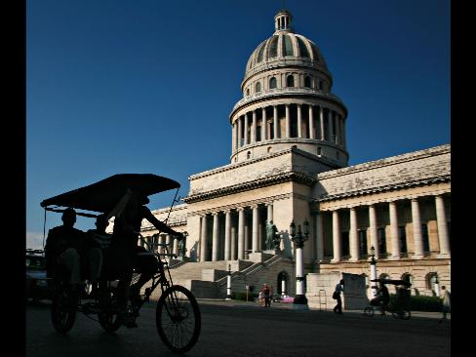
June 5 (Bloomberg) -- Cuba will rejoin the Organization of American States after “a lot of emotion” passes, said Ruben Blades, tourism minister in Panama, a member of the Washington- based group.
“There is a lot of emotion right now in the world,” Blades, also a six-time Grammy Award winning singer, said in an interview in New York. “So it’s a matter of processing. Eventually we will see a different scenario in Cuba as we have seen everywhere else.”
Blades’s prediction is at odds with the latest statements by Cuban officials. Cuba said yesterday it won’t seek to rejoin the OAS after the group of Western Hemisphere nations lifted its 47-year-old suspension, saying the OAS is irrelevant.
The OAS decision June 3 reflected a compromise between Latin American leaders, eager for President Barack Obama to lift its trade embargo against Cuba, and the U.S., which has pressed the communist nation to carry out democratic reforms.
The resolution stipulates that the communist country must still re-apply for membership and meet OAS standards for democracy and human rights.
Blades, 60, who plans to resume his musical career after leaving his post June 30, said he is hopeful the Obama administration will improve U.S. ties with Latin America after the country committed “a lot of mistakes in terms of the way it handled foreign policy” in the region.
‘Good Agenda’
“I do believe he is going to be able to create a good agenda for Latin America,” Blades said in the interview yesterday. “He managed to convey both proximity and at the same time authority” at the Trinidad and Tobago Summit of the Americas in April, he said.
The U.S. lifted all travel limits for Cuban-Americans visiting family in the island in April as well as restrictions on how much money they can send relatives there.
The OAS was founded in 1948. Cuba, the only country in the hemisphere that isn’t a democracy, has been excluded from OAS participation since 1962, according to the OAS Web site. The U.S. imposed an embargo on Cuba after Fidel Castro, who came to power in a 1959 revolution, expropriated land of U.S. citizens and companies and allied with the Soviet Union. Raul Castro succeeded his brother as president last year.
“The scenario in Cuba is going to change and the way we judge other societies is also going to change,” Blades said. “I don’t think that the invitation now for Cuba to join is just an empty gesture. It is the result of an evolution that has been occurring for decades.”
Presidential Run
Blades, who made an unsuccessful bid for president in 1994, said he doesn’t rule out running again. He served as tourism minister the past five years.
“Now I have administrative experience, which I did not have in 1994,” Blades said. “Everything is a five cushion shot, you can have the ball in front of the hole but you can’t put it in there. This is the way bureaucracy is conceived.”
Blades, whose last album, “Mundo,” won the 2002 Grammy for world music, plans to go back to his musical career, after spending the last five years without playing the guitar at home.
“I can’t afford another five years,” said Blades, adding he is returning to the private sector after accumulating debt as a public official. “I’ve got to do some of my own things.”
The minister said he won’t take any official position in the next government but will help his successor, Salomon Shamah.
“I don’t split my passions, because it makes me half or a third of what I am,” Blades said. “I have to concentrate in order to carry it through.”
To contact the reporters on this story: Fabiola Moura in New York at fdemoura@bloomberg.net. Eric Sabo in Panama City at esabo1@bloomberg.net.
Last Updated: June 5, 2009 09:04 EDT

